**Dream pizza**

**Specification**

Your program must meet the following specifications:

* The program contains options for the phone operator to specify whether the pizza order is for pickup or delivery.
* If the order is for delivery:
  + the program should collect the customer’s name, address and phone number
  + a $3 delivery charge should be added to the total cost
* If the order is for pick up:
  + the program should ask the phone operator to enter the customer’s name and phone number
* The program should allow the phone operator to input how many pizzas the customer would like (maximum 5 for any pizza).
* A menu of at least 12 pizza names should be presented to the phone operator.
* Each pizza to be ordered should be selected from the choices available on the menu and the order information should be stored.
* The cost of the first seven (regular) pizzas on the menu is $8.50 and the rest are $5 more as they are gourmet pizzas.
* When the order is finished:
  + the names of ordered pizzas and their individual prices should be displayed
  + the total cost of the order, including any delivery charge, should be displayed
  + customer name and phone number should be displayed
  + if the pizza is for delivery the address should be displayed.
* The program should allow the operator to cancel the order.
* After the order summary information has been displayed the program should be ready to accept another order or exit.

**Research Alternative:**

Paper:

A pizza ordering system on paper would not be sufficient

Database:

Database is known to be very sufficient with storing and collecting data. With database you can also change information and it can be stored in many different ways such as

Code:

Coding is the best option to create this pizza ordering system because

**Planning:**

Trello

|  |
| --- |
|  |
| This Trello board shows the first step of starting my project. One of the tasks were to create 3 different form layouts. I drew these form layouts to see the possible looks of each of my forms of customer details, menu and summary. Although these may not be the final product of how my forms may look, this gives the initial idea and what I need on my forms. |
|  |
| Here I have made more progress and have gotten feedback from the teacher for approval of my designs and any further comments needed for improvement. I have also done a flowchart to showcase my potential structural sequence of my project. |
|  |
|  |
|  |
|  |
|  |

**Relevant implications:**

Intellectual property

I will make sure all work is my own and will not copyright or take others work for my own use. This mean I cannot use other images and would have to create my own.

Social

Make sure all work is appropriate and does not come/ looked upon as offensive to anyone. On that note I will have to make it appeal to a range of age groups, genders and ethnicity.

Accessibility

How would I make this accessible to others? To do that I would have to consider people who have disabilities such as autism, epilepsy, dyslexia, colour-blindness etc. therefore it is accessibly for everyone.

Future proofing

I would need to make my program easy to update such as menu, price and others. My program can also be improved to a better code.

Ethical

Make sure my content does not cause any harm to anyone, such as violent images, pornographic images. Does not encourage bad choices and influences

Privacy

Make sure date is kept private and only should only be shown to members that should have access to the data. Such as use password.

End user

Make sure the program is working efficiently for the end user as well program laid out

Aesthetics

Make sure my program appeals to the correct audience and make sure to use any design conventions that suit the layout for a pizza menu

Legal

No copyrights and intellectual property of other can be used of other than mine.

Functionality

Make sure there no bugs and program load quickly. If the user clicks on one link can it lead quickly to the next link.

Usability

Make sure that my program design and code follows the heuristics of making it appeal to the end user and work efficiently and effectively. As well does the conventions relate to the real world so that end user is more familiar with the content.

Cultural

Use of appropriate/ variety of language for the end user. As for this program design for new Zealander, adding a second language such as te reo maori would make the program multi-cultural

|  |  |
| --- | --- |
| **Description** | **Flowchart** |
| Each of these shapes describes the process/step of my project. It should outline the major steps to create a flowchart that makes sense and shows the potential outline of my project. | Image result for flowchart shape meanings |
| This flowchart is a general sequence that roughly guides my code through each form. |  |
| This is a rough outline of my potential sequence of my project. This will essentially guide me through my project with each major step. |  |

Types of menus (pros and cons) 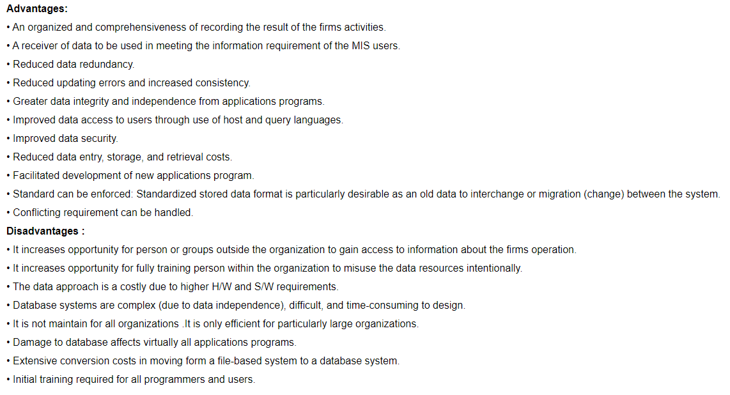

|  |
| --- |
|  |
| Design 1:  This is a rough idea of what my pizza ordering forms may look like. It has all the required sections and the basis of what is needed for the customer to place their order. I have notes on the side of it coloured in red that annotates what each section is used for. This is my first form that inputs the customer details and the menu. Although this may change. |
|  |
| The display of the summary has provided the essential details of the customer information and the ordered pizza from form 1. |
|  |
| Design 2:  This is my second design, I have moved the layout around to see what possibilities it would look better and use as much space as possible at the same time still look aesthetically pleasing. |
|  |
| This just shows the summary form where the pizza and customer details will be placed. |

|  |
| --- |
|  |
| Design 3:  This I the final design, overall I like the look of the customer details and how the menus layout. It is neat and tidy and generally have the basis of the requirements. I also got feedback from the teacher and other students in the class and they also I agreed on these form layouts, out of the other two previously. |
|  |
| I like this form better because I feel like the customer details should be at the top because it is the most important information that I want the |

ID of variables/ constants

|  |  |  |
| --- | --- | --- |
| **Variables:** | **Data type:** | **Reason of use:** |
| First and last name | Public sub: String | These texts have been set as string as it is easy to manipulate. I used this data type because string is commonly used for storing letters, words, or phrases. String is also very easy to operate and transform, which implies that it is easy to manipulate it. I |
| Unit | Public sub: String | These texts have been set as string as it is easy to manipulate. |
| Post Code | Public sub: String | These texts have been set as string as it is easy to manipulate. |
| Address | Public sub: string | These texts have been set as string as it is easy to manipulate. |
| City | Public sub: string | These texts have been set as string as it is easy to manipulate. |
| Suburb | Public sub: string | These texts have been set as string as it is easy to manipulate. |
| PhoneNumber | Public sub: string | These texts have been set as string as it is easy to manipulate. |
| Delivery | Public sub: string | These texts have been set as string as it is easy to manipulate. |
| DELIVERYFEE | Public sub: decimal | I set these constants to decimal because a decimal is a data type that represents non-repeating |
| TRADITIONALPRICE | Public sub: decimal |  |
| GOURMETPRICE | Public sub: decimal |  |

These are the variables I have thought about using in the first stages of my project, although I think I will be using more later on

|  |  |  |
| --- | --- | --- |
| **Pizza** | **Price** | **Quantity** |
| Beef & Onion | $8.50 | 0,1,2,3,4,5 |
| Cheesy Garlic | $8.50 | 0,1,2,3,4,5 |
| Hawaiian | $8.50 | 0,1,2,3,4,5 |
| Cheese | $8.50 | 0,1,2,3,4,5 |
| Ham & Cheese | $8.50 | 0,1,2,3,4,5 |
| Pepperoni | $8.50 | 0,1,2,3,4,5 |
| Vegetarian | $8.50 | 0,1,2,3,4,5 |
| BBQ Chicken | $13.50 | 0,1,2,3,4,5 |
| Garlic Prawn | $13.50 | 0,1,2,3,4,5 |
| Cheese Steak | $13.50 | 0,1,2,3,4,5 |
| Supreme | $13.50 | 0,1,2,3,4,5 |
| Margherita | $13.50 | 0,1,2,3,4,5 |

Relevant Implications:

Social:

I have contributed social implications in my code because I have not uploaded it publicly on git-hub, therefore would not cause any offence to social groups.

The overall aim of social implications is that a positive social impact, therefore I should consider the concepts and how it would affect any social groups. Considering age, gender, ethnicity. Makes sure that it does not cause offence to any social groups. My code should be socially constructed that it is non-offensive and that if it is connect to the internet and not uploaded publicly on git-hub for the public to view.

Aesthetics:

I have considered aesthetics by presenting my forms in neat and well structured format. I made sure that the text boxes and text are aligned with one another to prevent any unpleasant overall look. I made sure the colour of my forms we simply Gray to consider the people who suffer from colour blindness, therefore I took of any colour and just made it look simple and pleasant to the eye. I also thought about the text sizes for elders as they tend to have trouble reading smaller text sizes, as well the overall font has been kept constant throught my forms, they are simple and easy to read, nothing too fancy for others that have trouble reading the text.

The overall look of the forms should look neat and aesthetically pleasing. I should consider the colours, font and sizes of the text and the overall UI.

Accessibility:

In my forms I have considered the people who suffer from colour blindness, to which I decided to just not hace any colour on my forms. Even though my form is simply grey and black, with white I like the simplicity and how it offers accessibility to a more diverse audience.

Many people may suffer from colour blindness, so I need to consider and take to consideration the accessibility for these people. which means that I may need to may changes to my form look to make it more accessible to a more diverse audience.

Ethical:

I made my code ethical as it does not contain or produce any harmful, bad content such as violence and pornographic images.

To make my program ethical means that I must consider that what I produce may not cause any harm such encouraging/ showing any bad content such as violence and pornographic images.

Functionality:

The functionality of my code is very sufficient for the end user because it has buttons such as exit, return, confirm and so on for the program to stop, go to the next form, or go back and fix a mistake. This is very useful as it is necessary for customers to proceed on with their order and for the code to store the information inputted as well if the customer has a change of mind, it has the ability to go back and enable the data to be changed. Or is the customer doesn’t want the order at all and wants to exit the program, there will also be an exit button on the form for the customer to exit and terminate the program completely. Also when the program is running, at all times during the process of ordering the customer shouldn’t encounter any errors that will cause any difficulties for the end user to continue using the program. Therefore my program does not crash because the code is correct and functions as it should.

My program should load quickly that the customer does not need to wait for a long time to order or for the order to process. For it to work and function accordingly it should not crash at any times during the process of the end user using the program. As expected, it should input the data of the end user and then push it through to the summary form where it loads all previous information such as customer details and the pizzas ordered.

Usability:

I will make sure that the programs usability is efficient and has a function that works for end users that can go back to previous form to fix or change any information needed.